EXPERIMENT – 4

- Sequential Programming

Aim:
To write a C program that accepts two non-zero positive integers and displays their sum, difference, product, quotient, remainder, average, and square of their sum.

Algorithm
Start.
- Input two positive integers a and b.
- Calculate:
Sum = a + b
Difference = a - b
Product = a * b
Quotient = a / b
Remainder = a % b
Average = (a + b) / 2.0
Square of sum = (a + b) * (a + b)
- Display all results.
- Stop.

Pseudocode
START
INPUT a, b
sum = a + b
difference = a - b
product = a * b
quotient = a / b
remainder = a % b
average = (a + b) / 2.0
square = sum * sum
DI
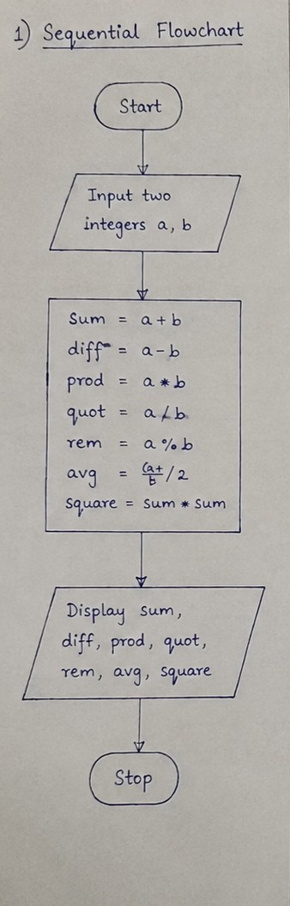

C Program:
#include <stdio.h>

int main()
{
int a, b, sum, difference, product, remainder, square;
float quotient, average;

printf("Enter two positive integers: ");
scanf("%d %d", &a, &b);

sum = a + b;
difference = a - b;
product = a * b;
quotient = (float)a / b;
remainder = a % b;
average = (a + b) / 2.0;
square = sum * sum;

printf("Sum = %d\n", sum);
printf("Difference = %d\n", difference);
printf("Product = %d\n", product);
printf("Quotient = %.2f\n", quotient);
printf("Remainder = %d\n", remainder);
printf("Average = %.2f\n", average);
printf("Square of Sum = %d\n", square);

return 0;
}

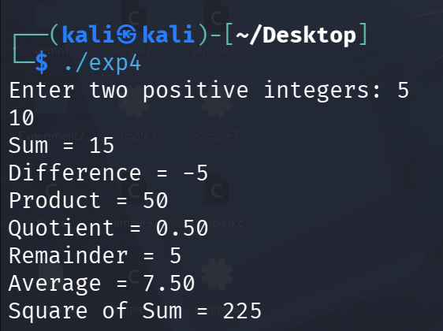

- Conditional Branching

Aim
To create a menu-driven C program that converts a temperature in Celsius to Kelvin, Fahrenheit, Reaumur, or Rankine using simple if statements.

Conversion Formulae:

1.
Celsius → Kelvin
K = C + 273.15

2.
Celsius → Fahrenheit
F = (C × 9/5) + 32

3.
Celsius → Reaumur
Re = C × 4/5

4.
Celsius → Rankine
R = (C + 273.15) × 9/5

Algorithm
- Start.
2.Input temperature in Celsius.
3.Display the conversion menu.
4.Input user's choice.
5.Use if statements to perform the selected conversion.
6.Display the converted temperature.
7.top.

Pseudocode
START
INPUT Celsius
DISPLAY conversion menu
INPUT choice

IF choice = 1
Kelvin = Celsius + 273.15

IF choice = 2
Fahrenheit = (Celsius * 9/5) + 32

IF choice = 3
Reaumur = Celsius * 4/5

IF choice = 4
Rankine = (Celsius + 273.15) * 9/5

DISPLAY result
STOP

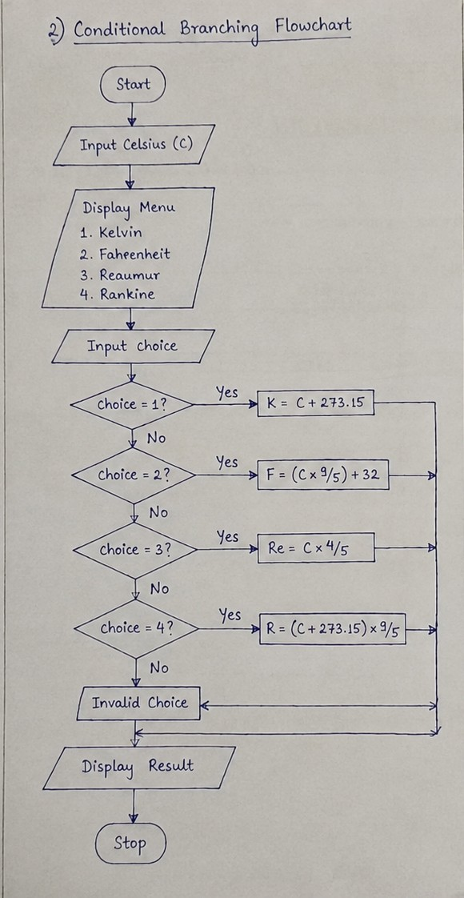

C Program

#include <stdio.h>

int main()
{
float c, result;
int choice;

printf("Enter temperature in Celsius: ");
scanf("%f", &c);

printf("1. Kelvin\n2. Fahrenheit\n3. Reaumur\n4. Rankine\n");
printf("Enter choice: ");
scanf("%d", &choice);

if(choice == 1) {
result = c + 273.15;
printf("Kelvin = %.2f\n", result);
}

if(choice == 2) {
result = (c * 9.0 / 5.0) + 32;
printf("Fahrenheit = %.2f\n", result);
}

if(choice == 3) {
result = c * 4.0 / 5.0;
printf("Reaumur = %.2f\n", result);
}

if(choice == 4) {
result = (c + 273.15) * 9.0 / 5.0;
printf("Rankine = %.2f\n", result);
}

return 0;
}

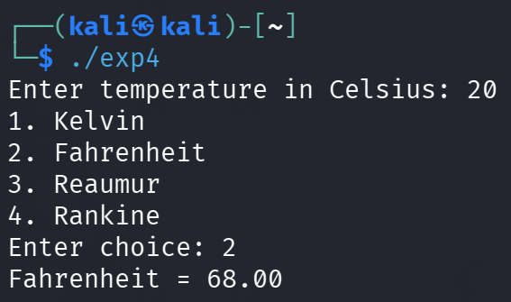

- Iterative looping

Aim
To input a positive integer, determine its number of digits using log10(), and use a for loop to calculate the sum and product of its digits.

Algorithm
1.Start.
2.Input a positive integer num.
3.Find number of digits using log10(num) + 1.
4.Initialize sum = 0 and product = 1.
5.Using a for loop:
- Extract digit using % 10.
- Add digit to sum.
- Multiply digit with product.
- Remove the last digit using / 10.
6.Display number of digits, sum, and product.
7.Stop.

Pseudocode
START
INPUT num
digits = log10(num) + 1
sum = 0
product = 1
temp = num

FOR i = 1 TO digits
digit = temp % 10
sum = sum + digit
product = product * digit
temp = temp / 10
END FOR

DISPLAY digits, sum, product
STOP
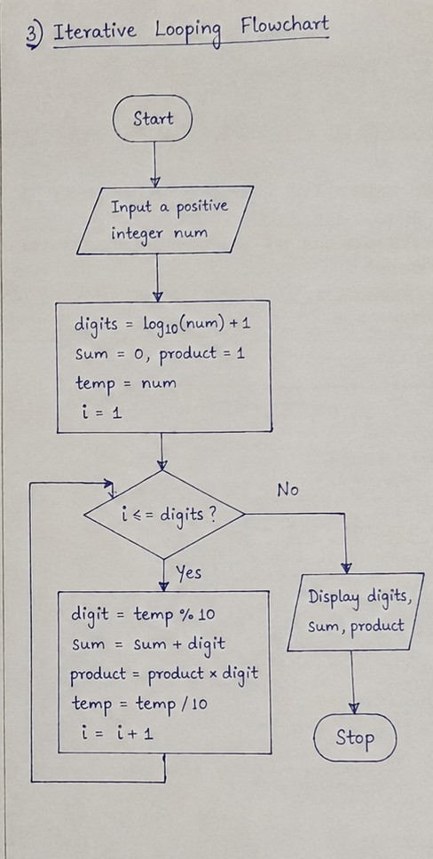
C Program
#include <stdio.h>
#include <math.h>

int main()
{
int num, temp, digits, digit;
int sum = 0, product = 1;

printf("Enter a positive integer: ");
scanf("%d", &num);

digits = (int)log10(num) + 1;
temp = num;

for(int i = 1; i <= digits; i++)
{
digit = temp % 10;
sum += digit;
product *= digit;
temp /= 10;
}

printf("Number of digits = %d\n", digits);
printf("Sum of digits = %d\n", sum);
printf("Product of digits = %d\n", product);

return 0;
}

